2017 Russell Family Fellowship Public Forum Lecture

Science and Religion Dialogue: A Personal Journey

Wednesday, March 8, 2017, 7pm
Dinner Board Room, Hewlett Library, Graduate Theological Union
2400 Ridge Road, Berkeley, California

This event is free and open to the public.
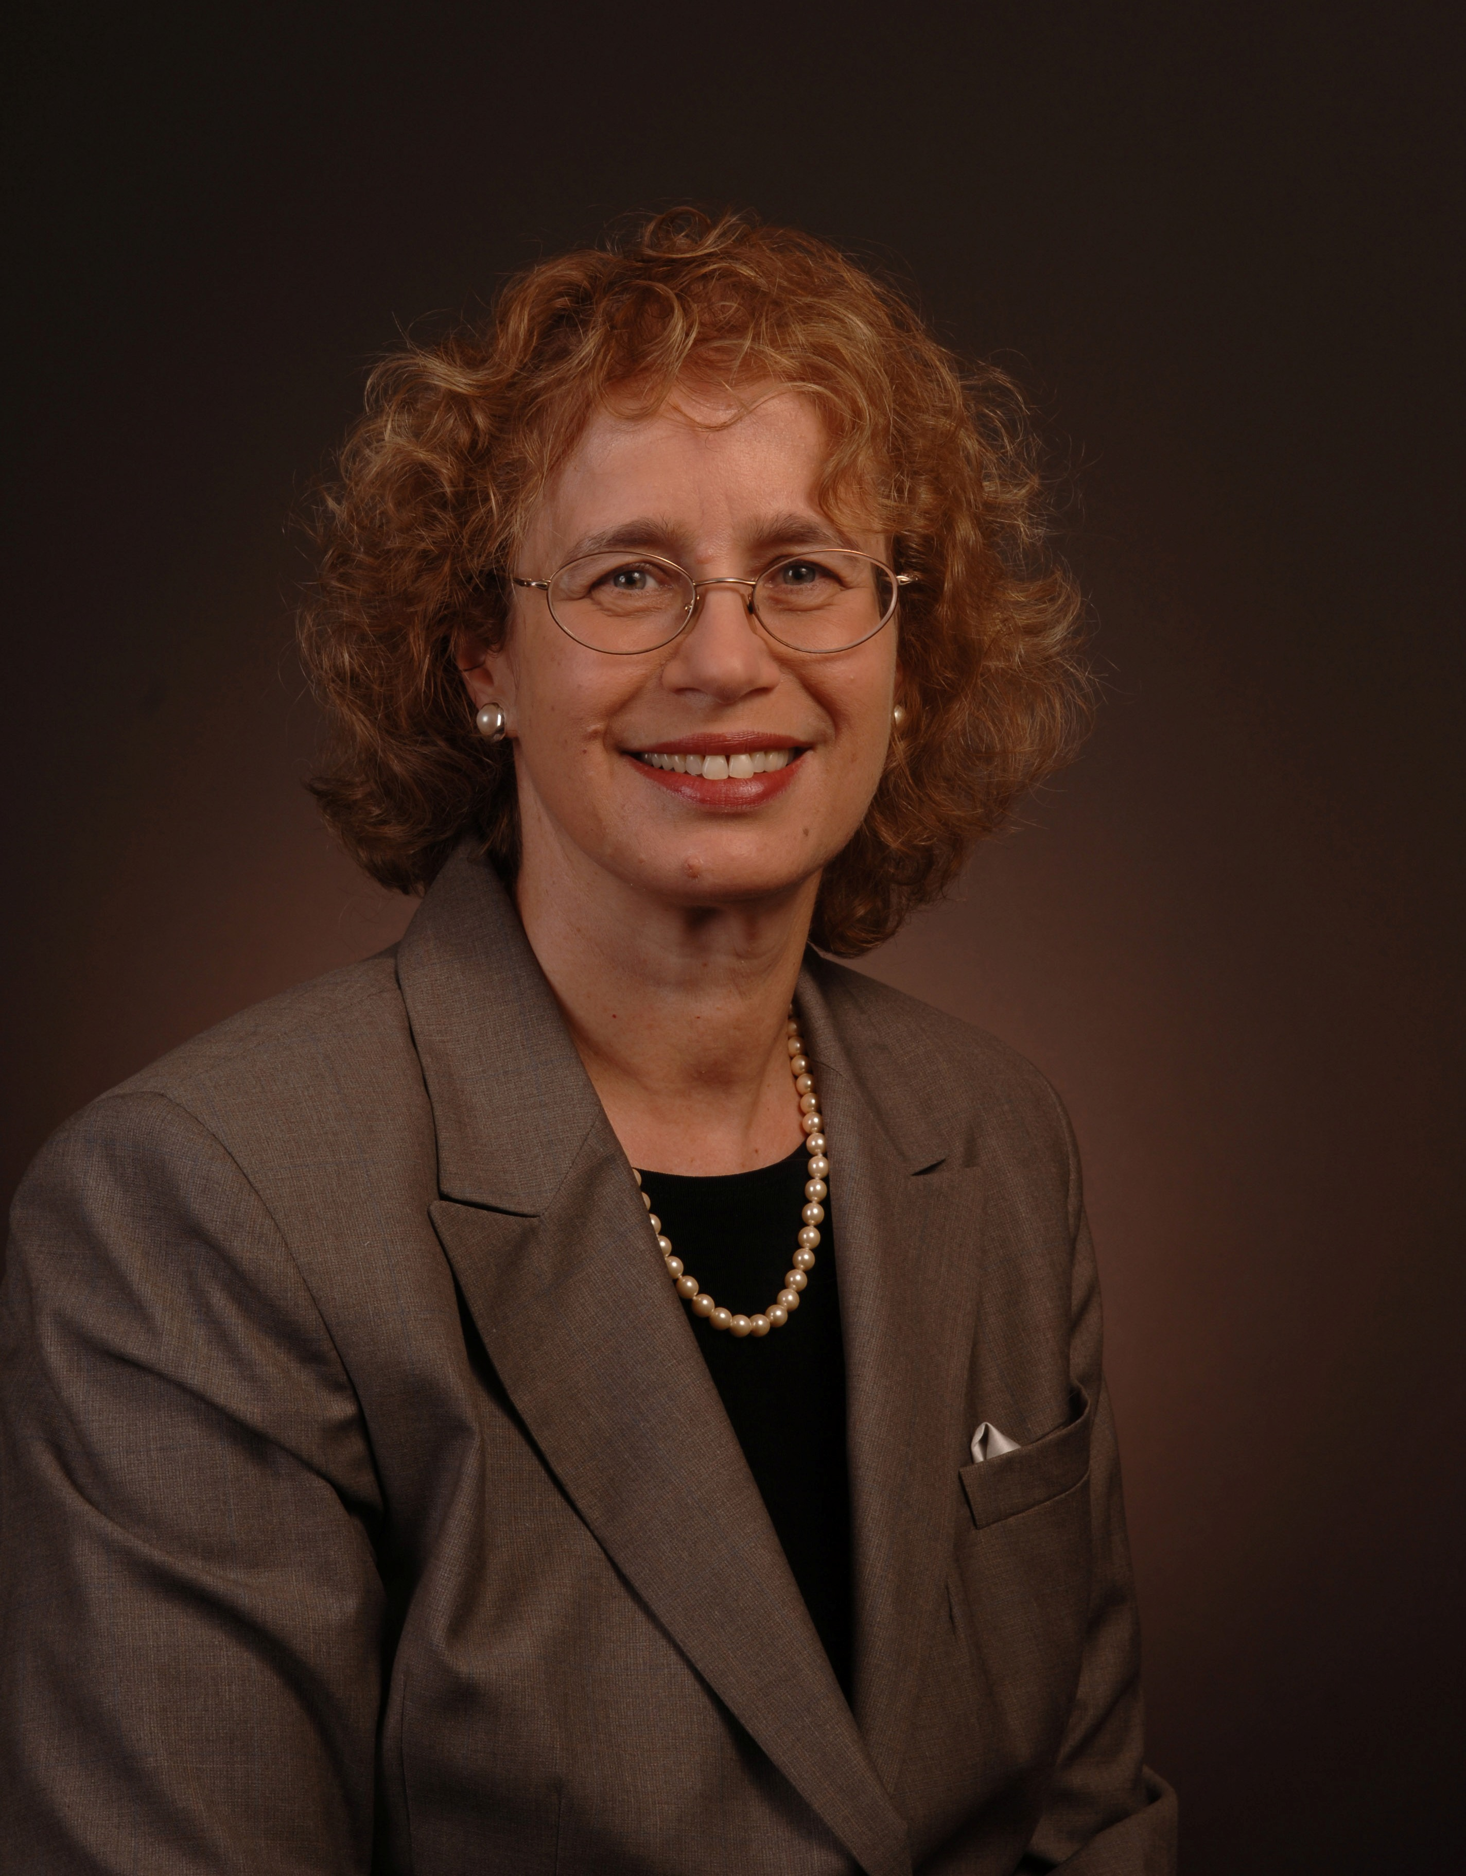
How did a secular, Zionist woman born in a kibbutz in Israel become involved in the field of science and religion? While telling a unique personal story, Dr. Tirosh-Samuelson will reflect on the place of science in Jewish history, the diverse perceptions of science in modern Judaism, and the limited interest of Jews in the science and religion and dialogue. Dr. Tirosh-Samuelson will argue that engaging the field of science and religion could enrich contemporary Jewish philosophy and theology, and, conversely, that Judaism could make a distinctive contribution to the field of science and religion.

Professor Hava Tirosh-Samuelson is Irving and Miriam Lowe Professor of Modern Judaism, the Director of Jewish Studies, and Professor of History at Arizona State University in Tempe, AZ. She holds a Ph.D. in Jewish Philosophy and Mysticism from the Hebrew University of Jerusalem (1978), and a BA in Religious Studies from SUNY-Stony Brook, New York (1974). Prior to joining the faculty of Arizona State University in 1999, she taught at Indiana University, Emory University in Atlanta, Columbia University in New York, and Hebrew Union College in New York.
Tirosh-Samuelson is a Jewish intellectual historian who focuses on the interplay of philosophy and mysticism, Judaism and science, and Judaism and ecology. In addition to over 50 essays and book chapters, she is the author of Between Worlds: The Life and Work of Rabbi David ben Judah Messer Leon (1991) which received the award of the Hebrew University for the best work in Jewish history for 1991, and the author of Happiness in Premodern Judaism: Virtue, Knowledge and Well-Being in Premodern Judaism (2003). She is also the editor of Judaism and Ecology: Created World and Revealed World (2002); Women and Gender in Jewish Philosophy (2004); Judaism and the Phenomenon of Life: The Legacy of Hans Jonas (2008); Building Better Humans? Refocusing the Debate on Transhumanism (2011); Hollywood's Chosen People: The Jewish Experience in American Cinema (2012); Jewish Philosophy for the Twenty-First Century: Personal Reflections (2014); and Perfecting Human Futures: Transhuman Visions and Technological Imaginations (2016). Professor Tirosh-Samuelson is the editor-in-chief of the LIBRARY OF CONTEMPORARY JEWISH PHILOSOPHERS (2013-2017), a series of 20 books featuring outstanding Jewish thinkers today.
Within the field of science and religion, she explores the interplay of religion, science and technology with a focus on transhumanism. She is the PI or Co-PI of several Templeton funded projects: 1) “Facing the Challenges of Transhumanism: Religion, Science, and Technology”; 2) “The Transhumanist Imagination: Innovation, Secularization and Eschatology”; and “Beyond Secularization: Piloting New Approaches for the Study of Religion, Science, and Technology in Public Life”. She is a member of International Society of Science and Religion (ISSR) and serves on the academic board of Zygon: Journal of Religion and Science. As Director of the Center for Jewish Studies at ASU, Tirosh-Samuelson manages the international society, Judaism, Science and Medicine Group (JSMG) and organizes its annual conferences.
The Center for Theology and the Natural Sciences (CTNS) is a Program of the Graduate Theological Union (www.ctns.org).
For more information please contact us at ctnsinfo@ctns.org.
2017 Russell Family Fellowship Research Conference

In Pursuit of Perfection: The Misguided Transhumanist Vision

Hava Tirosh-Samuelson

Thursday, March 9, 2017, 1:00-5:00pm
Registration required.
Dinner Board Room, Hewlett Library, Graduate Theological Union,
2400 Ridge Road, Berkeley, California

Transhhumanism is a secular ideology that invests technology with spiritual meaning. Presenting transhumanism as a pursuit for perfection of the human species, the lecture highlights the innate ambiguity of transhumanist discourse which treats perfection both as a stadial process of self-improvement as well as an end state of the process: the emergence of the posthuman species. The lecture highlights the main themes of transhumanist discourse -- human enhancement, morphological freedom, cyborgization, Singularity, and mind-uploading -- and argues that transhumanism is culturally significant but deeply misguided. The transhumanist pursuit of perfection by means of technology reflects the cross-currents of our post-secular age.
Professor Hava Tirosh-Samuelson is Irving and Miriam Lowe Professor of Modern Judaism, the Director of Jewish Studies, and Professor of History at Arizona State University in Tempe, AZ
Conference Respondents: Arvin Gouw, Brian Patrick Green, Stanley Klein and Ted Peters
Registration Required. To register please see www.ctns.org/jkr_fellow_pay.html. More information and the conference schedule can be found at http://www.ctns.org/jkr_fellow.html.

Other Russell Fellowship Events (free and open to the public):
- Jewish Environmentalism: Scholarship, Faith, and Activism, Tuesday, March 7, 2017, 5pm
Dinner Board Room, Graduate Theological Union Library
2400 Ridge Road, Berkeley, California, USA
(Sponsored by the Center for Jewish Studies, Graduate Theological Union)
- Science and Religion Dialogue: A Personal Journey
Wednesday, March 8, 2017, 7pm
Dinner Board Room, Graduate Theological Union Library
2400 Ridge Road, Berkeley, California, USA
The Center for Theology and the Natural Sciences (CTNS) is a Program of the Graduate Theological Union (www.ctns.org).
For more information please contact us at ctnsinfo@ctns.org.

